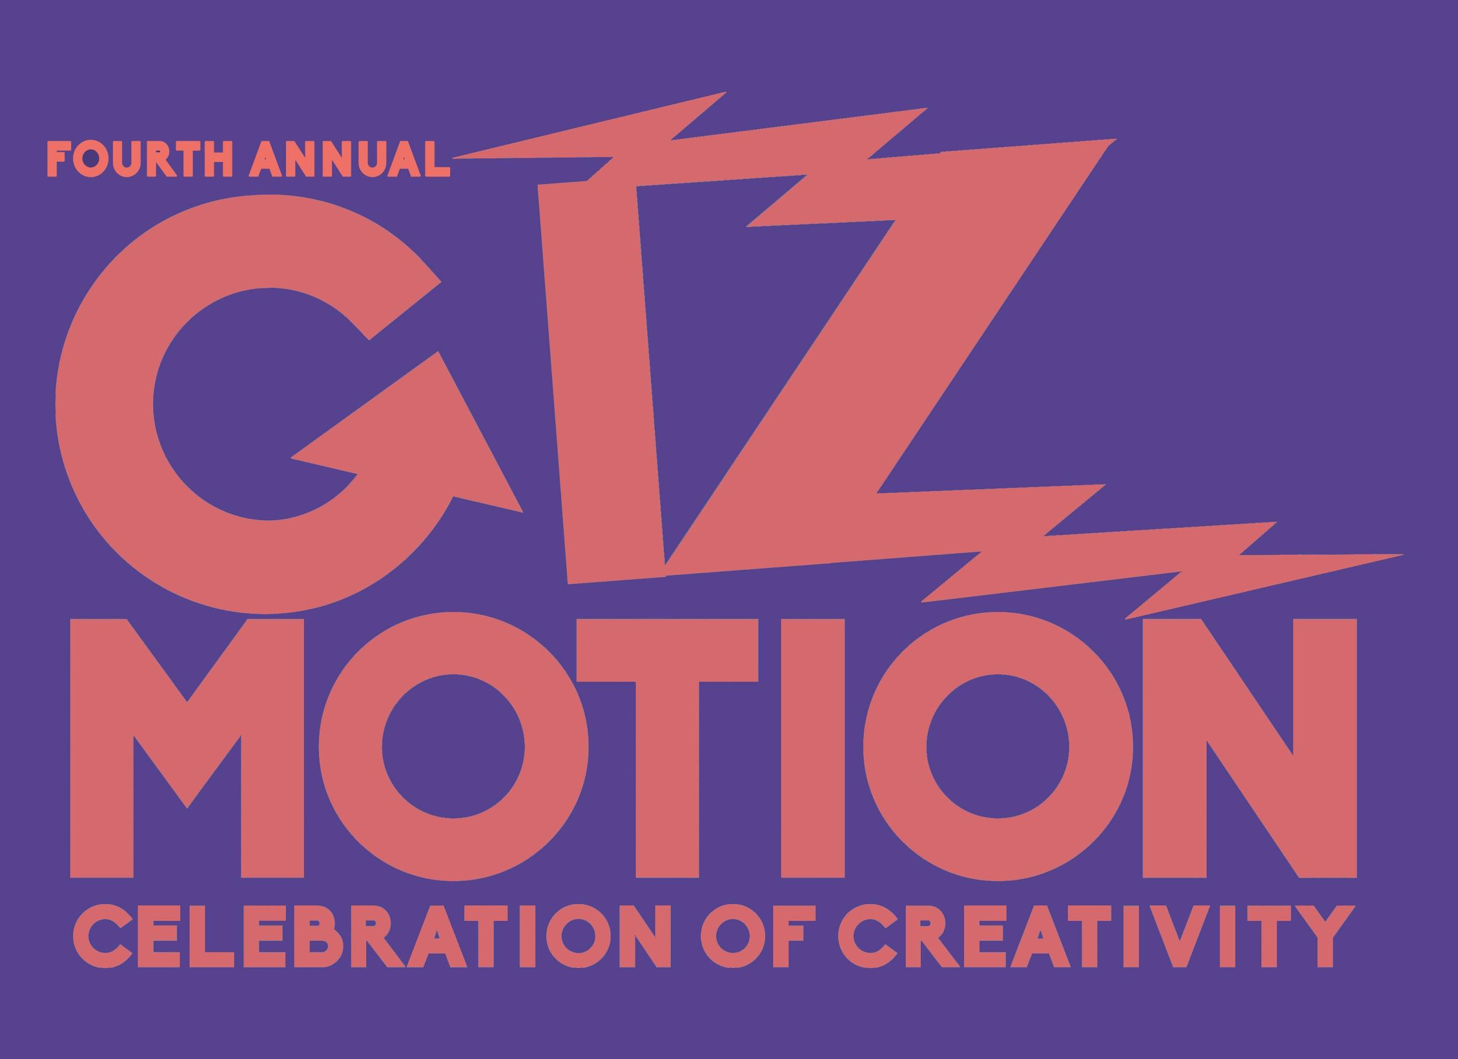 GizMotion 2018 Rules

THE 2018 CELEBRATION OF CREATIVITY WILL TAKE PLACE ON
SATURDAY, JULY 7TH, AT CITY PARK IN COEUR D’ALENE.
THE PARADE WILL BE AT 2:00PM.
AWARDS WILL BE GIVEN AT 3:30PM.

1. ALL sculptures must be human powered and:
Have wheels or movable legs
This year maybe foot powered (Flintstone styled) as well as peddled powered.
Be able to move forward, stop and turn.
May have battery power for spectacularness of lights but not for movement
May participate in costume.

2. You must be able to keep up with a 3 mph minimum speed. If you can’t keep up, you can’t participate.

3. The course will traverse a circle around City Park

4. Sculptures must be no larger than 102 inches (8′ 6′′) wide,12 ft high, and 18 ft long.

3. Sculptures must not pose any direct danger to anything near it, no open flame, no pointy things, also the pilot must be able to escape quickly and safely.

4. Sculptures must be decorated in a recognizable theme, or unrecognizable, as long as it is glorious. The pilots and pit crew must also be in appropriate costumes.

5. Sculptures must be able to stop safely and quickly.

6. Sculptures must stay on course with the escorts, those that detour for any reason other than break down will be disqualified.

7. Pilots that begin the event with a sculpture, must stay with the sculpture, no rotating.

8. All Participants must be sober while operating their vehicle, there will be plenty of time after the course is complete for revelry!

9. Any vehicle with a logo or business name will be required to pay an additional entry fee.

10. Judging will be based on glory and glory alone, unaffected by sponsors or any other parties besides judges.

11. Participants must follow the directions of event coordinators, volunteers, police escorts, etc..

12. In order to have FUN, we need to be SAFE!

13. Smile and enjoy this amazing experience!!

KINETIC VEHICLE ENTRY INFO:
Adult Vehicle Entry Fee: Suggested $25 donation
Kid Vehicle Entry Fee: Suggested $5 (Kids are 18 years old or younger) donation
Bling Your Bike Suggested donation $5 per family...

