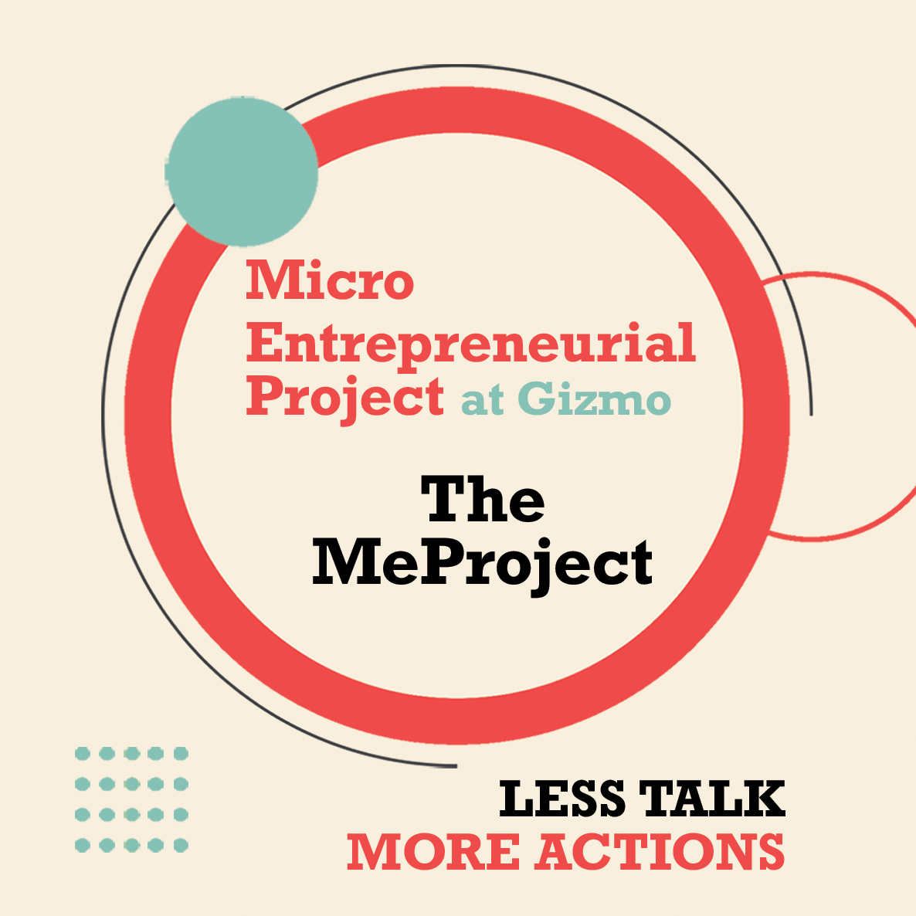
MeProject Mentors
Chris Angel | Owner Groundswell Agency, high-performance business coaching, marketing messaging specialty
Will Hockett, | Owner of Critical-Data specialty in research analysis expertise, in-depth qualitative market research.
Brittany Ratelle | Trademark Attorney, specializes in artist and makers
Sarah McCracken | CPA and business development specialist
Melissa Kaiserman | Owner A Time for Everything, nationally recognized instructor Dave Ramsey Business Boutique on Etsy digital Market Space, owner of the Tech Gal
Jamie Morgan | instructor & Business Coach SBA
Dean Miles | Small Business Owner and Instructor
Numerica | Financial Literacy
Jackie Maker | Owner Jackie Maker Consulting business consultant & coach, owner Jackie Maker Designs handmade jewelry business.
Donna Hockett | Owner of Shabby Chic Marketplace, SEO specialty, website builder and digital marketing,
Josh King | Owner Tinder Box Marketing, Instructor and national recognition teaching on Amazon Marketplace
Kyle Rutley | Owner of Wake Media, video, website digital marketing
Jen Boehm | Owner Leather Bird, Podcast host of the Maker podcast
Isaac Cunningham | Artesian Entrepreneur
Barbara Mueller | Principal MSM Design, Maker
Erik Satren | Maker
Sheila Biegler | Maker
Jordan Bader | Maker

